*****U*NIVERSITY OF *I*NFORMATION *T*ECHNOLOGY & *S*CIENCES (*UITS* )**

**ASSIGNMENT**

**on**

**INTERNET OF THINGS LAB**

⮘**Submitted To**⮚

***Ayanava Paul***

Lecturer,

Department of CSE, UITS

⮘**Submitted By**⮚

***F*AZLAY *R*ABBI**

* Department 🢣 CSE
* ID 🢣 2125051070
* Semester 🢣 Autumn 2024
* Batch 🢣 50
* Section 🢣 7B1
* Subject Code 🢣 CSE 402
* Date of Submission 🢣 23.09.2024

**Signature**

Display Information using UNO R3

Title: Display your name and student ID in the first and second row respectively of the LCD. Also show them in serial monitor.

Necessary Equipment: 1. Arduino UNO R3

2. 5. 16*2

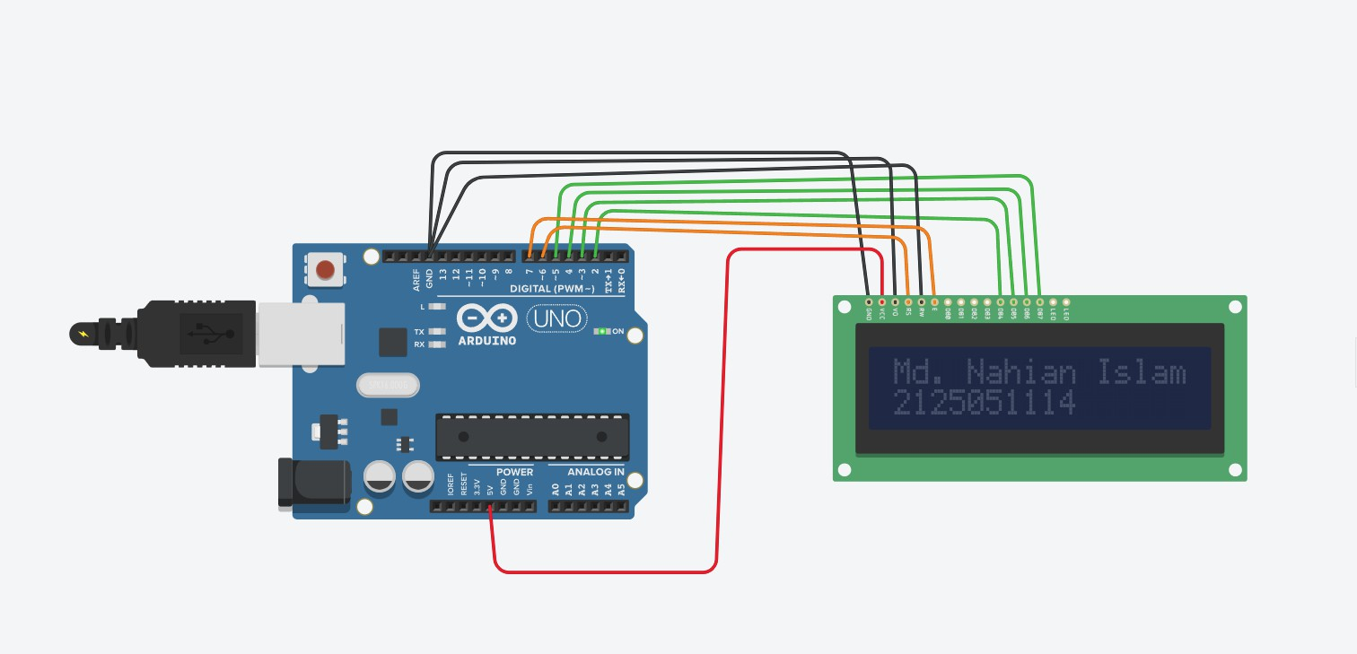

Code:

#include <LiquidCrystal.h>

char a[] = "Md. Nahian Islam";

char id[] = "2125051114";

LiquidCrystal lcd(6,7,2,3,4,5); //Rs,E,D4,d5,D6,D7 void setup()

{

lcd.begin(16,2);

Serial.begin(9600);

}

void loop()

{

lcd.setCursor(0,0); lcd.print(a); lcd.setCursor(0,1); lcd.print(id); Serial.println(a); delay(1000); Serial.println(id); delay(1000);

}

Even, odd position light blink

Title: Build a mini LED array project with Arduino where at first the LEDs at odd position will be blinked serially. Then the LEDs at an even

position will be blinked serially. Take 5 LED

Necessary Equipment:

1. Arduino UNO R3

2. Breakbord

3. 330 Ohom resistor

4. 5LED

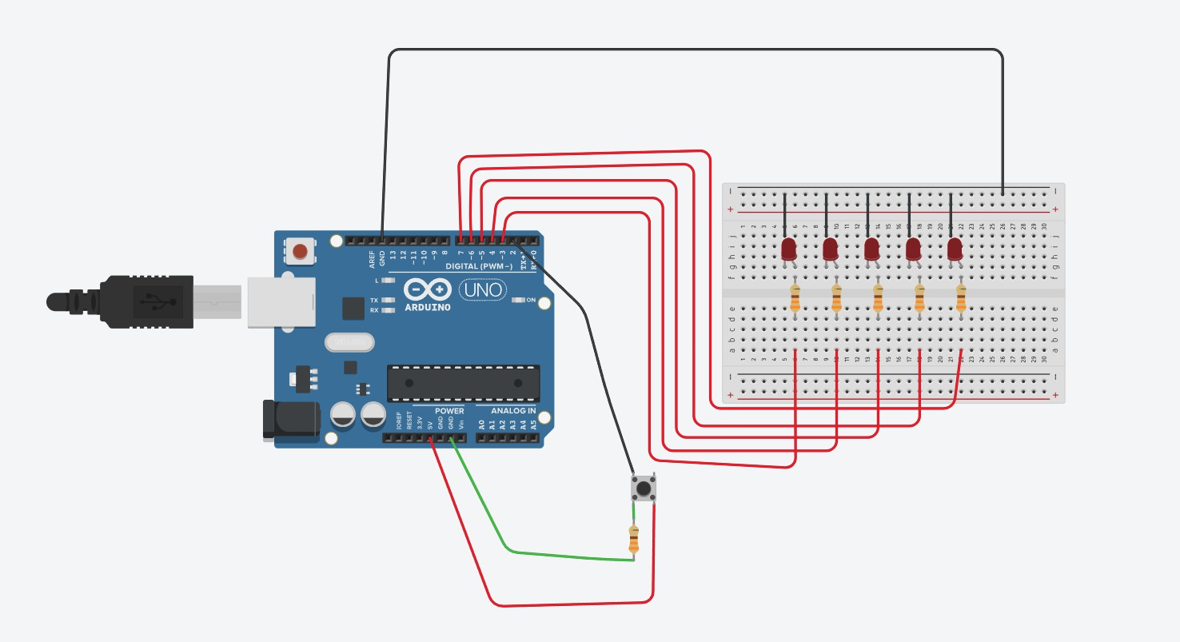

Code:

